<https://arxiv.org/pdf/1509.00318.pdf>

Data from the l = 30◦ survey region, which contains the massive star-forming regions W43 and G29.96

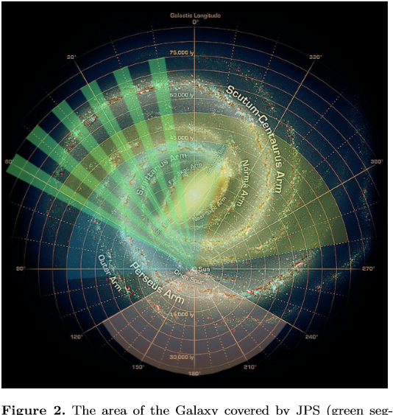

[2] <https://www.eaobservatory.org/jcmt/science/legacy-survey/jps/>

**JCMT Galactic Plane Survey**

The basic science goal of the JPS is to achieve a full census of star-formation activity in the plane of the Galaxy observable from JCMT, to a detected mass limit of around 40 solar masses at the far edge of the Galaxy. Given this limit and the latitude range (equivalent to the scale height of OB stars at ~3kpc), the specific science goals are related to high-mass star formation and can be grouped under four main headings, two of which are ‘triggering and the star-forming content of molecular clouds’ and ‘Cold Dark Clouds and the formation of molecular clouds’

**Cold Dark Clouds** and the formation of **molecular clouds**: In order to understand star formation we need to determine the process that produces the molecular clouds in which stars form. Cold Dark Clouds (CDCs) contain both atomic and molecular gas and have densities and temperatures that bridge the gap between the ambient atomic ISM and cold, dense molecular clouds. CDCs may therefore be sites of formation of molecular clouds out of the turbulent neutral medium.

[7] <https://www.eaobservatory.org/jcmt/>

With a diameter of 15m the James Clerk Maxwell Telescope (JCMT) is the largest astronomical telescope in the world designed specifically to operate in the submillimetre wavelength region of the spectrum. The JCMT is used to study our Solar System, interstellar and circumstellar dust and gas, and distant galaxies. It is situated at approximately [19°49’22.2″N 155°28’37.0″W](https://www.google.com/maps/place/19%C2%B049%2722.2%22N+155%C2%B028%2737.0%22W/@19.822842,-155.47695,4485m/data=!3m1!1e3!4m2!3m1!1s0x0:0x0?hl=en) close to the summit of Maunakea, Hawaii, at an altitude of 4092m.

## Telescope

The 15-metre diameter primary reflector of the JCMT is made up of 276 individual lightweight panels.

<https://en.wikipedia.org/wiki/James_Clerk_Maxwell_Telescope>

The **James Clerk Maxwell Telescope** (**JCMT**) is a [submillimetre-wavelength](https://en.wikipedia.org/wiki/Submillimetre_astronomy) telescope at [Mauna Kea Observatory](https://en.wikipedia.org/wiki/Mauna_Kea_Observatory) in [Hawaii](https://en.wikipedia.org/wiki/Hawaii), US. The telescope is near the summit of [Mauna Kea](https://en.wikipedia.org/wiki/Mauna_Kea) at 13,425 feet (4,092 m). Its primary mirror is 15 metres (16.4 yards) across: it is the largest single-dish telescope that operates in submillimetre wavelengths of the electromagnetic spectrum ([far-infrared](https://en.wikipedia.org/wiki/Far_infrared_astronomy) to [microwave](https://en.wikipedia.org/wiki/Microwave)).[[1]](https://en.wikipedia.org/wiki/James_Clerk_Maxwell_Telescope#cite_note-Holland-1) Scientists use it to study the [Solar System](https://en.wikipedia.org/wiki/Solar_System), [interstellar dust](https://en.wikipedia.org/wiki/Cosmic_dust) and [gas](https://en.wikipedia.org/wiki/Interstellar_medium), and distant [galaxies](https://en.wikipedia.org/wiki/Galaxy).

<https://en.wikipedia.org/wiki/Submillimetre_Common-User_Bolometer_Array>

Two instruments known as the **Submillimetre Common-User Bolometer Array**, or **SCUBA**, have been used for detecting submillimetre radiation on the James Clerk Maxwell Telescope in Hawaii

[8] <https://www.herschel.caltech.edu/>

The Herschel Space Observatory's mission was designed to unveil a face of the early Universe that was previously hidden. Thanks to its ability to detect radiation at far infrared and sub-millimetre wavelengths, Herschel was able to observe dust obscured and cold objects that are invisible to other telescopes.

Herschel's major objective was discovering how the first galaxies formed and how they evolved to give rise to present day galaxies like our own. Additional targets for Herschel included clouds of gas and dust where new stars are being born, disks out of which planets may form and cometary atmospheres packed with complex organic molecules.

[3] <https://arxiv.org/pdf/1001.2106.pdf>

**This one seemed useful**

**Hi-GAL, the Herschel infrared Galactic Plane Survey**, is an Open Time Key Project of the Herschel Space Observatory. It will make an unbiased photometric survey of the inner Galactic Plane by mapping a two-degree wide strip in the longitude range | l |< 60◦ in ﬁve wavebands between 70µm and 500µm. The aim of Hi-GAL is to detect the earliest phases of the formation of molecular clouds and high-mass stars and to use the optimum combination of Herschel wavelength coverage, sensitivity, mapping strategy and speed to deliver a homogeneous census of star-forming regions and cold structures in the interstellar medium. The resulting representative samples will yield the variation of source temperature, luminosity, mass and age in a wide range of Galactic environments at all scales from massive YSOs in protoclusters to entire spiral arms, providing an evolutionary sequence for the formation of intermediate and high-mass stars

The Herschel photometric cameras PACS (Poglitsch et al. 2008) and SPIRE (Griﬃn et al. 2009) will be used in parallel mode (pMode1) to maximize survey speed and wavelength coverage. Due to the instruments wavelength multiplexing capabilities, one pMode observation delivers maps at ﬁve different wavelengths: 70 and 170µm with PACS and 250, 350 and 500µm with SPIRE. Both cameras cameras use bolometric detector arrays to map the sky by scanning the spacecraft along approximate great circles.

3.2. Molecular cloud formation

About a quarter of the mass in the ISM is in molecular form (Blitz 1997) and most of that material resides in giant molecular clouds (GMCs). Since GMCs are also the dominant sites of star formation, understanding their origins and evolution is essential to our understanding of the Galactic environment.

<https://en.wikipedia.org/wiki/Spectral_energy_distribution>

A **spectral energy distribution** (**SED**) is a plot of energy versus frequency or wavelength of light (not to be confused with a 'spectrum' of flux density vs frequency or wavelength).[[1]](https://en.wikipedia.org/wiki/Spectral_energy_distribution#cite_note-1) It is used in many branches of astronomy to characterize astronomical sources. For example, in [radio astronomy](https://en.wikipedia.org/wiki/Radio_astronomy) they are used to show the emission from [synchrotron radiation](https://en.wikipedia.org/wiki/Synchrotron_radiation), [free-free emission](https://en.wikipedia.org/wiki/Free-free_emission) and other emission mechanisms. In [infrared astronomy](https://en.wikipedia.org/wiki/Infrared_astronomy), SEDs can be used to classify [young stellar objects](https://en.wikipedia.org/wiki/Young_stellar_object).

[6] <https://royalsocietypublishing.org/doi/pdf/10.1098/rsta.1902.0012>

* Collapsing under its own weight

<http://web.b.ebscohost.com.ezproxy.kpu.ca:2080/ehost/ebookviewer/ebook/bmxlYmtfXzM0Nzg1NV9fQU41?sid=1fc5f869-50f0-4e87-b48c-a251b6b05a15@pdc-v-sessmgr06&vid=0&format=EB&rid=1>

[**APA**](http://web.b.ebscohost.com.ezproxy.kpu.ca:2080/ehost/ebookviewer/ebook/bmxlYmtfXzM0Nzg1NV9fQU41?sid=1fc5f869-50f0-4e87-b48c-a251b6b05a15@pdc-v-sessmgr06&vid=0&format=EB&rid=1)

(American Psychological Assoc.)

References

Ward-Thompson, D., & Whitworth, A. P. (2011). *An Introduction to Star Formation*. Cambridge University Press.

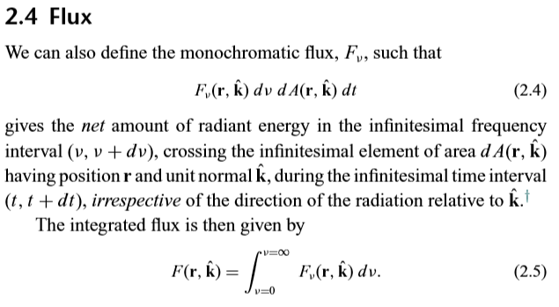  
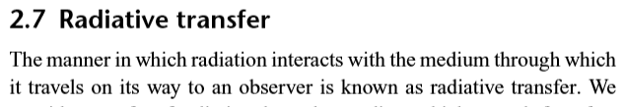

<https://arxiv.org/pdf/1704.02982.pdf>

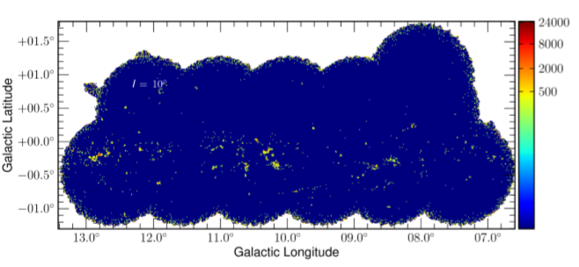

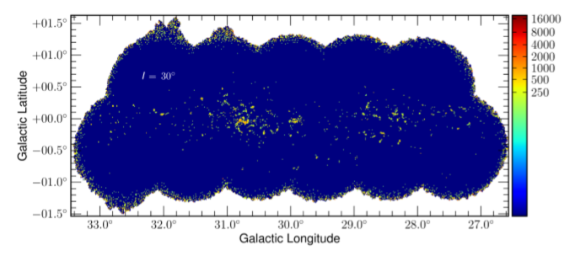

Figure 1. The JPSPR1 maps for the ﬁrst three ﬁelds, `=10◦, 20◦ and 30◦. The intensity scale is in units of mJybeam−1. Several areas can be seen where the SCUBA-2 instrument continued to take data beyond the edge of the standard circular pong3600 tile. These excursions are visible at the edges of most of the ﬁelds and the `=10◦ ﬁeld is misshapen in the top right tile. This extension is caused by the inclusion of a trial observation taken prior to the main survey that has a small positional offset from the standard grid pattern. Signiﬁcant regions can be observed in each ﬁeld with W31 found at `=18.25◦,b=-0.19◦, W39 at `=18.86◦,b=-0.48◦ and G29 and W43 found at `=29.95◦,b=-0.02◦ and `=30.75◦,b=-0.05◦, respectively

[4] <https://arxiv.org/pdf/0705.3765.pdf>

It was the advent of modern infrared and millimeter-wave technology in the latter half of the twentieth century that cemented the relation between Dark Clouds and the formation of stars and planetary systems.

The discovery of molecules in space further revealed that Dark Clouds are made of molecular material with H2 as the dominant constituent (Weinreb et al. 1963; Wilson et al. 1970)

their molecular composition and their opaque optical appearance

Molecular clouds are dark not because of their hydrogen molecules, but because of a population of tiny solids (“dust grains”) that absorb the optical starlight and lead to high visual extinctions (AV > 1m). Such a dimming of the starlight reduces the heating eﬀects from external radiation and results in temperatures a few degrees above the 2.7 K cosmic background (T ∼ 10 K)

more massive Giant Molecular Clouds that form rich stellar clusters and contain embedded massive stars that heat the surrounding gas to temperatures > 20 K.

Near infrared observations can be used to extend the optical extinction measurements to the most opaque regions of clouds thanks to the wavelength dependence of the dust absorption

Arrays like SCUBA on the JCMT, MAMBO on the IRAM 30m telescope, and Bolocam on the CSO have made it possible to map systematically the thermal emission of cold dust from dark clouds (e.g. Motte, Andr´e & Neri 1998; Johnstone et al. 2000; Enoch et al. 2006)

submillimeter (submm) observations of dark clouds are sensitive to a narrower range of dust temperatures and suﬀer from severe instrumental limitations.

In general, dark clouds have highly irregular edges, and their overall appearance is ﬁlamentary and often wind-blown

Dark clouds, therefore, seem to be born with a ﬁlamentary distribution of material that extends over a number of parsecs. As clouds evolve and form stars, the products of star formation inherit the ﬁlamentary distribution of the parental gas (Hartmann 2002).

[5] <https://arxiv.org/pdf/astro-ph/9902246.pdf>

Molecular clouds are generally self-gravitating, magnetized, turbulent, compressible ﬂuids.

These clumps themselves contain dense cores which are the localized sites of star formation within the cloud (Myers & Benson 1983)

In this picture, the hierarachy of cores within clumps within clouds is simply an observational categorization of this self-similar structure

Most of the mass of the molecular ISM is in the form of giant molecular clouds (GMCs)

Molecular clouds are regions in which the gas is primarily molecular.

Star-forming clumps are the massive clumps out of which stellar clusters form

<https://courses.lumenlearning.com/astronomy/chapter/star-formation/>

Molecular clouds have a complex filamentary structure, similar to cirrus clouds in Earth’s atmosphere, but much less dense. The molecular cloud **filaments** can be up to 1000 light-years long. Within the clouds are cold, dense regions with typical masses of 50 to 500 times the mass of the Sun; we give these regions the highly technical name ***clumps***. Within these clumps, there are even denser, smaller regions called **cores.** The cores are the embryos of stars. The conditions in these cores—low temperature and high density—are just what is required to make stars.